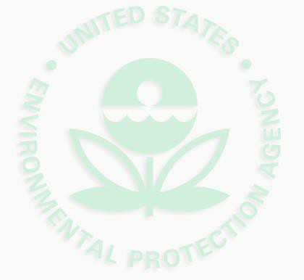

Final Updates to
National Ambient Air Quality Standards
(NAAQS)
for Ozone

Society of Women Environmental Professionals
Jody Ostendorf
January 21, 2016

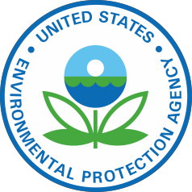
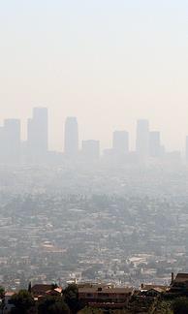
What we’ll cover

- Updated Standards

2015 Final Ozone Standards
Primary: 70 ppb
Secondary: 70 ppb
- Health Effects of Ground-Level Ozone
- Ozone’s Impact on the Environment
- Benefits and Costs of Meeting the Revised Standards
- How the Standards are Implemented
- Current Status of our Region 8 States

Updated Standard– Primary

The Clean Air Act charges the EPA Administrator with setting primary standards that are requisite to protect public health with an adequate margin of safety.
In setting the primary standard, the Administrator:
- Examined the body of scientific evidence on ozone and health
  - Evidence expanded significantly since EPA last reviewed the
ozone standards in 2008.
- Focused on new studies that have become available since 2008.
  - New clinical studies -- provide the most certain evidence of health effects, and clearly show ozone at 72 ppb can be harmful to healthy, exercising adults.
  - Clinical studies also show effects in some adults following exposures as low as 60 ppb; however, there is uncertainty that these effects are adverse. 3

Primary Standard, cont.

- The Administrator also reviewed results of analyses of exposure to ozone and looked at how different levels of the standard would reduce risk.
  - Analyses take into account how people are exposed to ozone in their
daily lives.
  - Focused on risks to children, particularly due to repeated exposures to ozone.
- Considered advice from the Clean Air Scientific Advisory
Committee (CASAC) and public comment on the proposal.
  - CASAC concluded that the science supports a standard within a range of 70 ppb down to 60 ppb, noting that the decision about what standard provides the adequate margin of safety is a judgment left to the Administrator.

4

Updated Standard – Primary (cont.)

- Based on the science, the Administrator has determined that the 2008 standard was not adequate to protect public health.

Revised standard of 70 ppb:
  - Is requisite to protect public health with an adequate margin of safety.
  - Is below the level shown to cause adverse health effects in the clinical studies.
  - Essentially eliminates exposures shown to cause adverse health effects, protecting 99.5 % of children from even single exposures to ozone at 70 ppb.
  - Substantially reduces exposures to levels lower than 70 ppb, reducing
multiple exposures to 60 ppb by more than 60%.

5

Secondary Standard

- EPA also is strengthening the secondary (welfare) standard to 70 ppb.
- New studies add to evidence that repeated exposure to ozone reduces growth and has other harmful effects on plants and trees. These types of effects have the potential to harm ecosystems.

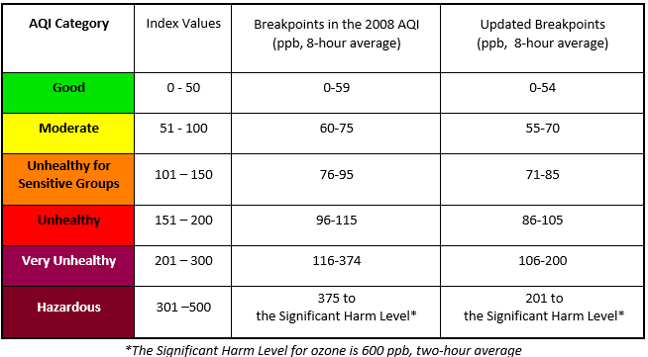
Air Quality Index at AirNow.gov

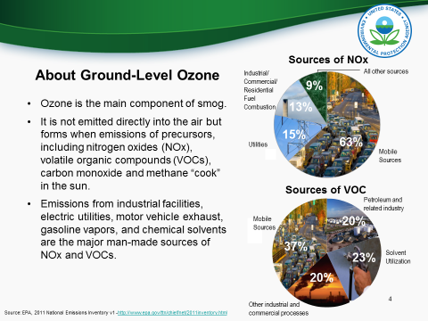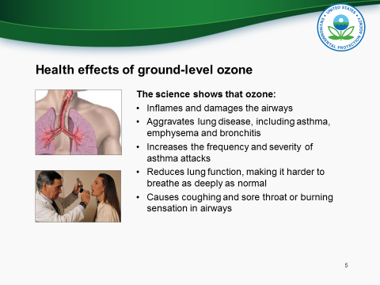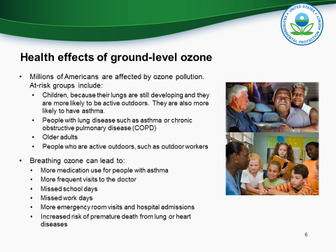
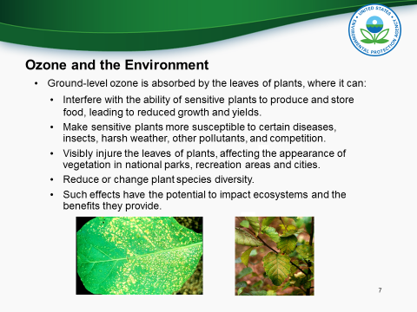
Mo Benefits and Costs of Meeting the New Standard

- EPA estimates that meeting the standards in 2025 will yield annual health benefits of $6.4 to $13 Billion at the standard of 70 ppb.
- This includes the value of preventing significant health effects in children and adults.
- EPA estimates that the annual costs would be $3.9 billion.

Note: This does not include California, which is on a different implementation schedule.

Updates

Avoided Health Effects per year:

- 710-1,400 premature deaths (adults and children)
- 320,000 asthma exacerbation (children 6-18)
- 790 acute bronchitis (children 8-12)
- 24,000 upper and lower respiratory symptoms (children 7-14)
- 330,000 school loss days (children 5-17)
- 1,400 asthma emergency room visits (adults and children)
- 510 respiratory hospital admissions (adults)
- 180 cardiovascular hospital admissions (adults)
- 65,000 days when people miss work (adults)
- 1.3 million days when people must restrict their activities (adults)
- 64-600 nonfatal heart attacks (adults)

Implementation: Memo from Acting Assistant
Administrator

- EPA will work state, tribal, local and federal agencies to implement the updated standards in a way that maximizes common sense, flexibility and cost-effectiveness, while following the requirements of the Clean Air Act.
- Memo issued with the revised standards, outlines the agency’s plans for addressing issues related to:
  - Guidance available to agencies;
  - Ensuring major source permitting is effective and efficient;
  - Designating areas;
  - Background ozone;
  - Interstate ozone transport;
  - The challenges of reducing ozone in California;
  - Managing monitoring networks;
  - Emissions from wildland fires; and
  - Transportation planning

Upcoming Implementation-Related
Rules/Guidance/Activities

- Area designations guidance (including rural transport areas)
- Nonattainment area classifications and attainment dates rule
- Updates to nonattainment area SIP requirements rule,
including possible anti-backsliding provisions for 2008 NAAQS
- Nationwide interstate transport contribution assessment
- Updates to transportation conformity guidance
- White paper and workshop on background ozone issues
- PSD permitting

Implementation Rules: Translation/Interpretation

- Would cover any necessary updates to the 2008 Ozone NAAQS State Implementation Plan Requirements Rule.
  - Status of petitions for reconsideration and review.
- Update the SIP due dates for emissions inventories, RACT, attainment plans/demos, RFP plans, contingency measure plans, section 185 programs.
- Address ongoing implementation for 2008 NAAQS, including revoking the 2008 NAAQS and anti-backsliding provisions.

24

Designations and Implementation: Tentative Timeline

Attainment Schedule by Classification
Classification | Schedule*
Marginal | 3 years to attain
Moderate | 6 years to attain
Serious | 9 years to attain
Severe | 15 to 17 years to attain
Extreme | 20 years to attain

*Areas must attain as expeditiously as practical, but not later than the schedule in the table. Two one-year extensions are available in certain circumstances based on air quality.
Designation Schedule
 | Schedule | Tentative Date
State and Tribe Recommendations | Within 1 year after NAAQS promulgation | October 1, 2016
EPA responds to state and tribal recommendations |  | June 1, 2017
Final Designation | Within 2 years after NAAQS promulgation (Administrator has discretion to extend the deadline by one year to collect sufficient information.) | October 1, 2017 Effective date may vary. (Air quality data years: 2014 –2016)
Implementation Schedule
Infrastructure SIP | Within 3 years after NAAQS promulgation | October 2018
Attainment Plans Due | Within 36 - 48 months after designations depending on classification | October 2020-2021

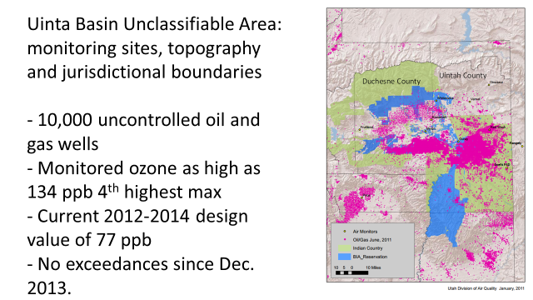
U&O FIP

- EPA Region 8 is proposing to promulgate a Federal Implementation Plan (FIP) under the Clean Air Act (CAA) specific to the U&O Reservation. In the FIP, the EPA proposes to regulate volatile organic compound (VOC) emissions from existing facilities in the production segment of the oil and natural gas sector that are located on Indian country lands in the Uinta Basin.

- Approximately 98 percent of VOC and 60 percent of NOx emissions released in the Uinta Basin are from existing oil and natural gas production operations. Furthermore, approximately 78 percent of oil and natural gas sources are on Indian country lands and are largely unregulated, with no control obligations.

- The proposed requirements in this FIP are intended to address the two concerns of compromised air quality in the Uinta Basin and inconsistent regulatory requirements across the U&O Reservation and State of Utah jurisdictions.

- The proposed FIP would result in an almost 40 percent reduction of VOC emissions, and would help mitigate the area’s potential future nonattainment designation.
Emission Inventory Effort

- Region 8 is working with the State of Utah and the Ute Indian Tribe to develop an emission inventory (EI) on tribal land for the Uinta Basin’s future ozone nonattainment area.

- We developed a workbook which will serve as a single, multi-jurisdictional data warehouse for emissions data. We sent it to all operators in the Uinta Basin in August and we have thus far received emissions data covering 97% of sources.

- We are currently doing a Q/A of the information and following up with individual operators to ensure we ultimately will have the most robust, accurate emission inventory.

Wyoming’s Upper Green River Basin Marginal Nonattainment Area

- Currently attaining the 2008 standard with a preliminary 2013-2015 design value of 67.

- Wyoming recently finalized an Oil and Gas Existing Source Permit by Rule in the Upper Green River Basin. The rule became State-effective June 30, 2015. Facilities are currently looking into applicability issues and installing control equipment, if appropriate. The compliance deadline for control installation is Jan 1, 2017.

Denver North Front Range Nonattainment Area

- Area did not meet its July 20, 2015 Marginal area attainment date
- Preliminary 2013-2015 design value is 80 ppb; Will be bumped up to moderate classification at the end of February 2016
- Any controls implemented by the area must be in place by January 1, 2017, which is January 1st of the fifth year after the effective date of designation.
- The SIP needs to come in as soon as possible, no later than January 1, 2017.

The revised SIP must include the following moderate area requirements:
- An attainment demonstration
- Provisions for RACT and RACM
- Reasonable Further Progress (RFP) reductions in VOC and NOx emissions
- Contingency measures to be implemented in the event of failure to meet a milestone or attain the standard

Questions?

Thank You!
31

